NEW TOEFL SET 9

Module 1
Reading
Fill in the blank
Questions 1-10
Immigration has reshaped communities around the world throughout modern history. Immigrant ¹ popul_ _ _ _ _ _ have ² exper_ _ _ _ _ _ ³ com_ _ _ _ ⁴ soc_ _ _ ⁵ a_ _ ⁶ econ_ _ _ _ challenges ⁷ th_ _ require balancing new ⁸ poli_ _ _ _ _ realities ⁹ wi_ _ preserving cultural ¹⁰ tradi_ _ _ _ _. These adjustments often span multiple generations before full integration occurs. Researchers continue studying how such processes unfold across different regions.

Questions 11-20
Lions are social animals that live in groups called prides on African grasslands. A ¹ ma_ _ lion typically ² estab_ _ _ _ _ _ a ³ la_ _ _ ⁴ terr_ _ _ _ _ ⁵ span_ _ _ _ many miles ⁶ a_ _ ⁷ regu_ _ _ _ _ patrols its boundaries. ⁸ T_ _ dominant cat must ⁹ lo_ _ for intruders across hundreds of ¹⁰ squ_ _ _ kilometers to protect his pride. These patrols help ensure that rival males do not challenge his position or threaten the cubs. Successful territorial defense is essential for a male lion’s reproductive success.

Read in Daily Life (Webpage)
Questions 21-22
www.westbrook.edu/library/hours
Westbrook University Morrison Library – Hours & Services
The Morrison Library is the main research facility on campus, housing over 2 million print volumes and providing access to 300+ online databases.
House of Operation:
Monday-Thursday: 7 A.M. – 11 P.M.
Friday: 7 A.M. – 6 P.M.
Saturday-Sunday: 10 A.M. – 5 P.M.
Extended Hours During Finals: The library remains open 24 hours from the last week of classes through the final examination period. All students must present a valid university ID to enter after 9 P.M. Visitors may use reading rooms during regular daytime hours but cannot borrow materials.

21. When does the library close on Fridays?
- At 7 A.M.
- At 6 P.M.
- At 9 P.M.
- At 11 P.M.
22. What are visitors allowed to do at the library?
- Borrow books for up to one week
- Access online databases remotely
- Use reading rooms during the day
- Enter the building after 9 P.M.

Read in Daily Life (Email)
Questions 23-24
To: Team
From: Daniel Reyes, Team Leader
Subject: Resume Review Request – Career Fair Candidates

Dear Team,
I attended the Greenfield University career fair on Monday and collected 12 resumes from promising candidates. Please review the attached files and submit your feedback through the evaluation portal by Friday at 5:00 P.M. Your assessments will help us select applicants for first-round interviews next Wednesday.

Best regards,
Daniel Reyes
Team Leader

23. What does Mr. Reyes require his team members to do?
- Attend a university career fair
- Schedule interviews with applicants
- Evaluate candidate materials
- Update the hiring portal
24. When will the first-round interviews be held?
- On Monday
- On Wednesday
- On Friday
- On Saturday

Read in Daily Life (Notice)
Questions 25-27
Data Science Program – Fall Course Guide
The Center for Data Analytics is pleased to offer a range of courses for the upcoming fall semester. Please review the following information to determine which class best suits your background and goals.
Beginner Level
Prerequisites: None
This course provides an introduction to core data science concepts, including data collection, basic analysis, and interpretation. Classes A, B, and C cover identical content but are offered at different times and formats to accommodate various schedules.
Class | Schedule | Time | Format
Class A | Mon/Wed | 10:00 A.M. | In-person only
Class B | Tue/Thu | 2:00 P.M. | Online only
Class C | Wed/Fri | 4:00 P.M. | In-person only

Intermediate Level
Prerequisites: Basic statistics or prior data science coursework
This course covers machine learning fundamentals, predictive modeling, and algorithm design. Students will gain hands-on experience with industry-standard tools and techniques.
Class | Schedule | Time
Class D | Mon/Wed | 1:00 P.M.
Class E | Tue/Thu | 10:00 A.M.

Advanced Level
Prerequisites: Completion of Class D or E
This research seminar is designed for students conducting independent projects. It is required for all thesis candidates in the data science program.
Class F: Friday, 9:00 A.M.

Special Course
Prerequisites: None
This course focuses on creating compelling infographics and presenting data findings to diverse audiences. Students will learn effective techniques for communicating complex information visually.
Class G: Thursday, 6:00 P.M.

Registration opens September 1st. For questions, contact datascience@westfield.edu.
25. Michael has no data science background, is unavailable on Mondays and Thursdays, and does not have reliable internet access at home. Which class would be most appropriate for him?
- Class A
- Class B
- Class C
- Class D
26. Alex has completed an introductory statistics course along with some intermediate data science courses. He intends to write a thesis. Which class should Alex take?
- Class C
- Class D
- Class F
- Class G
27. Who is most likely to be interested in class G?
- A marketing manager who presents reports to clients
- A software developer interested in machine learning
- A doctoral candidate preparing a research project
- A high school teacher new to data science

Read in Daily Life (Notice)
Questions 28-30
Greenwood University Literature Club – Fall Semester Recruitment
The Greenwood University Literature Club is now accepting applications for new members for the fall semester. We welcome students from all majors who share a passion for reading and discussing literary works.
About the Club
- The Literature Club was founded in 2015 and currently has over 60 active members.
- We meet every Tuesday evening from 6:00 P.M. to 8:00 P.M. in Humanities Hall, Room 204.
- Each month, members vote on a book to read and discuss together.
- Past selections have included classic novels, contemporary fiction, and poetry collections.
Membership Benefits
- Members receive priority registration for guest author lectures and literary workshops hosted by the English Department.
- Additionally, members are eligible to submit their own creative writing to the club's annual publication, The Greenwood Review.
How to Join
- Interested students should complete an application form available at the Student Activities Office or online at greenwood.edu/litclub.
- Applications must be submitted by Friday, September 15th.
- There is no membership fee for the fall semester.
For questions, contact the club president, Rachel Kim, at litclub@greenwood.edu.

28. What is the main topic of the notice?
- An announcement of upcoming guest author lectures
- A call for submissions to a literary publication
- An invitation to join a student organization
- A schedule change for club meetings
29. According to the notice, what is one benefit of joining the club?
- Free access to all English Department courses
- Early registration for certain campus events
- A discount on books selected for discussion
- Automatic publication of creative writing submissions
30. What is indicated about the membership fee?
- It varies depending on the student’s major.
- It will increase starting next semester.
- It is waived for first-time applicants.
- It is not required for the current term.

Academic Passage
Questions 31-35
Augmented Reality in Employee Training
Augmented reality technology is revolutionizing how companies train employees for complex and potentially hazardous tasks. By overlaying digital information onto the physical environment, AR systems enable workers to practice dangerous procedures without real-world risks. This approach proves especially valuable in industries where mistakes can result in serious injury or equipment damage.
AR training environments allow learners to repeat difficult tasks as many times as needed while receiving immediate feedback on their performance. Studies have shown that this iterative practice significantly improves both learning speed and long-term retention. Medical students who practiced surgical techniques through AR simulations, for instance, demonstrated proficiency scores thirty percent higher than peers trained with traditional methods. At automotive plants, workers reduced assembly errors by nearly half after completing AR-guided modules, suggesting that virtual practice translates effectively to actual job performance.
However, widespread adoption of AR training faces significant obstacles. The initial investment for hardware, specialized software, and system maintenance remains prohibitively expensive for many small and medium-sized businesses. Organizations also struggle to find personnel qualified to design effective AR curricula. Despite these challenges, costs continue to decline as the technology matures, and growing demand is expanding the pool of skilled developers.

31. The word “revolutionizing” in paragraph 1 is closest in meaning to
- challenging
- opposing
- analyzing
- transforming

32. The passage states that medical students who used AR simulations
- completed their training in half the time required by traditional programs
- achieved significantly higher scores on proficiency assessments
- expressed a strong preference for virtual learning environments
- were permitted to perform procedures without direct supervisions
33. What can be inferred from the passage about the relationship between AR training and workplace tasks?
- Competencies acquired through virtual practice can apply to real work situations
- AR training benefits only those in medical professions
- Conventional instructional approaches have become obsolete
- Factory employees need more extensive AR instruction than healthcare workers
34. Why does the author mention studies about AR training?
- To explain the technical mechanisms underlying AR systems
- To contrast various AR platforms used across industries
- To provide evidence that AR training yields measurable improvements
- To trace the historical evolution of AR in educational contexts
35. According to paragraph 3, what represents a barrier to the broad implementation of AR-based employee training?
- The technological complexity exceeds the capabilities of most workers
- Virtual environments cannot adequately replicate hazardous workplace conditions
- Empirical research has demonstrated superior outcomes with conventional instructional approaches
- The financial resources required for acquisition and upkeep exceed what numerous enterprises can afford

Module 2
Reading
Fill in the blank
Questions 1-10
Cosmology is the scientific study of the universe's origin, structure, and ultimate fate. This field ¹ exam_ _ _ _ distant ² gala_ _ _ _ and ³ pla_ _ _ _ through mathematical ⁴ mod_ _ _ ⁵ wh_ _ _ help explain cosmic ⁶ eve_ _ _. It ⁷ desc_ _ _ _ _ ⁸ id_ _ _ that are ⁹ wid_ _ _ accepted based on careful ¹⁰ observ_ _ _ _ _ _ of celestial phenomena. Advanced telescopes and space probes have revolutionized our understanding of deep space. These technological advances continue to shape modern astrophysical research in profound ways.

Academic Passage
Questions 11-15
Benefits of Green Roofs
Green roofs, which feature layers of vegetation planted on building rooftops, have gained increasing popularity in urban planning as a strategy for addressing environmental challenges. These living systems offer multiple benefits that extend well beyond simple aesthetics.
One significant advantage is increased energy efficiency. The layer of soil and plants provides natural insulation, substantially reducing heat transfer through the roof structure. During summer months, green roofs can lower indoor temperatures by several degrees, diminishing the need for air conditioning and reducing energy consumption.
Green roofs also help combat the urban heat island effect, a phenomenon where cities become significantly warmer than surrounding rural areas due to heat- absorbing surfaces like asphalt and concrete. By replacing these dark surfaces with vegetation, green roofs reflect more sunlight and release moisture through evapotranspiration, effectively cooling the surrounding air.
Additionally, rooftop gardens enhance ecological diversity by providing habitat for insects, birds, and other wildlife in otherwise barren urban environments. Some cities have also begun using green roofs for urban food production, growing vegetables and herbs that supply local restaurants and community markets.
However, green roofs require substantial initial investment and ongoing maintenance costs. The added weight of soil and vegetation also demands reinforced structural support, which can limit installation options for older buildings.
11. The word “diminishing” in paragraph 2 is closest in meaning to
- eliminating
- addressing
- lessening
- stabilizing
12. According to the passage, how does the vegetation layer on green roofs contribute to energy efficiency?
- It completely prevents heat from entering buildings during all seasons
- It functions as insulation that decreases the transfer of heat
- It generates electricity through photosynthetic processes in plants
- It absorbs excess moisture that would otherwise damage roof materials
13. What can be inferred from the passage about conventional urban surfaces such as asphalt and concrete?
A. They retain less thermal energy than vegetated surfaces during daylight hours
B. They contribute to elevated temperatures in metropolitan areas
C. They have been largely replaced by green infrastructure in most cities
D. They are more cost-effective than green roofs for urban development
14. Why does the author mention "vegetation" in the discussion of the urban heat island effect?
A. To contrast plant biology with the physical properties of synthetic materials
B. To explain the mechanism by which green roofs counteract urban warming
C. To argue that all urban areas should mandate vegetated roof installations
D. To describe the aesthetic improvements green roofs provide to cityscapes
15. Look at the four letters (A, B, C, and D) in the passage that indicate where the following sentence could be added. Where would the sentence best fit?
Sentence to insert: "These factors must be carefully weighed against the environmental and economic benefits described above."
- Position A
- Position B
- Position C
- Position D

LISTENING SECTION
MODULE 1
Questions 1-12


Listen to the question and select the best response from the choices.

A. I usually study in the library.
B. It’s on the second floor, near the elevators.
C. The building was innovated last year.

D. It’s open until midnight during finals.

- A. At ten o’clock, I believe.
B. The topic is really interesting.
C. I think it’s in Hall B this week.

D. The professor is new this semester.

- A. I joined the team last month.
B. We’re meeting in the usual room, right?
C. Well, we can always start with whoever shows up.

D. Sarah said she might bring snacks.

- A. I saw him at the cafeteria earlier.
B. He’s always forgetting things.
C. The office supply store closes at six.

D. There’s a supply closest down the hall.

- A. The classroom is on the third floor.
B. The bulb might need replacing.
C. I prefer natural lighting.
D. The switch is right by the door.

- A. There’s a kiosk by the main entrance.
B. The train departs at six.
C. I usually drive to work.
D. A round trip is about forty dollars.

- A. My phone battery is almost dead too.
B. Did you check the circuit breaker?
C. That would explain why the streetlights are off too.
D. I was in the middle of watching something.

- A. The class is in room 201.
B. I enjoy the lectures.
C. Did I miss anything important?
D. I overslept.

- A. The presentation went really well.
B. I think Group B is scheduled first.
C. The schedule should be posted online.
D. The conference room is upstairs.

- A. I’m still working on the conclusion.
B. the seminar was very informative.
C. It’s supposed to be at least ten pages.
D. The topic is on climate change.

- A. I think the game is almost over.
B. The show starts at eight.
C. Sure, no problem.
D. What channel is this on?

- A. The group project is due Friday.
B. Everyone’s been so busy with midterms.
C. The library closes at nine.
D. How about next Tuesday instead?

Questions 13-14
Listen to a conversation.

- What are the speakers mainly discussing?
- The woman’s academic project progress
- A request for a deadline extension
- A professor’s grading policies
- Research methodology problems

- When will the man be available to help the woman?
- This weekend
- In three weeks
- After the final presentation
- Next week

Questions 15-16
Listen to a conversation.

- What problem does the man have?
A. He forgot to make a reservation.
B. His equipment reservation was not recorded.
C. The microscope he needs is broken.
D. He missed his biology lab session.

16. What will the woman probably do next?
A. Contact the biology department
B. Reserve a different microscope
C. Postpone the man's experiment
D. Look up the man's booking information

Questions 17-18
Listen to a conversation.

- Why does the man want to participate in the garage sale?
A. He wants to help the woman move.
B. He needs money for new furniture.
C. He has items he wants to sell.
D. He enjoys meeting new people.

18. What can be inferred about the woman?
A. She has never held a garage sale before.
B. She has experience selling items this way.
C. She prefers to donate rather than sell.
D. She is planning to move soon.

Questions 19-20
Listen to an announcement.

19. What is the main topic of the announcement?
A. A membership recruitment drive for a campus club
B. A game design workshop for interested students
C. A social gathering hosted by a club
D. A competition between organizations

20. What are attendees asked to bring?
A. Board games from home
B. Snacks to share
C. A registration fee
D. Their student IDs

Questions 21-22
Listen to an announcement.

21. What is the main purpose of the announcement?
A. To introduce visiting lecturers to students
B. To announce a new peer review assignment
C. To remind students of upcoming project deadlines
D. To inform students about a room change

22. What can be inferred about students in this class?
A. They will need to go to a different building
B. They should register for the lecture series soon
C. They can skip class on Monday if needed
D. They will receive extra credit for attending

Questions 23-24
Listen to an announcement.

23. Which of the following is true about the Health Sciences Shadowing Program?

A. It is available to students from any major
B. Participants will observe professionals weekly
C. The program runs during summer break
D. Students will assist with medical procedures

24. What should students include in their application?

A. Two faculty recommendation letters
B. A health screening report
C. Prior volunteer experience documentation
D. Immunization records and a personal statement

Questions 25-28
Listen to a talk.

25. What is the main topic of the talk?

A. The historical development of Newton's laws of motion
B. How moving objects overcome air resistance during turns
C. Different techniques cyclists use to increase their speed
D. How leaning helps maintain balance in turns

26. According to the speaker, what does the law of inertia state?

A. Objects in motion tend to continue straight
B. Heavier objects require more force to stop completely
C. Objects naturally slow down over time without applied force
D. All motion eventually comes to rest

27. What determines how much a cyclist must lean during a turn?

A. The weight of the bicycle and rider
B. The surface material of the road
C. Speed and curve sharpness
D. The direction of the wind

28. What will the speaker discuss next?

A. How Newton discovered the laws of motion
B. Road and track design applications
C. Safety equipment commonly used by cyclists
D. The key difference between bicycles and motorcycles

Questions 29-32
Listen to a talk.

29. What is the talk mainly about?

A. The history of dice games in educational settings
B. A tool for sparking ideas and interaction
C. How to become a professional fiction writer
D. Traditional methods of overcoming writer's block

30. What does the speaker say is central to creative thinking?

A. Making unexpected connections
B. Following established story structures
C. Working independently without prompts
D. Planning narratives carefully in advance

31. Why does the speaker mention social gatherings?

A. To explain where picture dice were invented
B. To argue that writing is better done in groups
C. To compare professional and casual storytelling
D. To show another use of the dice

32. What will the speaker discuss next?

A. How to manufacture picture dice at home
B. Other icebreaker activities for social events
C. The psychology behind visual learning styles
D. A former student's work using this method

Module 2
Questions 1-3

Listen to the question and select the best response from the choices.

1.
A. I think it starts at three.
B. The tutoring center is in the library.
C. Yes, I registered online yesterday.
D. I heard spots fill up fast.
2.
A. It's in the administration building.
B. I applied for a scholarship last semester.
C. The deadline was extended.
D. You can also apply online now

3.
A. I'm leaning toward biology.
B. The deadline to declare is next month.
C. My advisor suggested I take a semester off.
D. Engineering requires the most credits.

Questions 4-5
Listen to a conversation.


4. What happened to the woman recently?

A. She dropped a linguistics course.
B. She received a spot in a seminar.
C. She changed her major to linguistics.
D. She met with Professor Hammond.

5. What does the woman suggest the man do?

A. Email the professor directly
B. Attend the first class anyway
C. Wait until next semester
D. Prepare an alternative course option


Questions 6-7
Listen to a conversation.

6. What is the man’s main concern?

A. His rent is increasing significantly.
B. His apartment is too far from work.
C. His lease is about to expire.
D. His landlord is difficult to contact.

7. What can be inferred about the man?


A. He plans to move to a new city soon.
B. He recently started a new job.
C. He has a history of paying rent on time.
D. He prefers to live with roommates.

Questions 8-10
Listen to a talk.
8. What aspect of bird behavior does the speaker mainly discuss in this talk?

A. The physiology adaptations that allows birds to fly long distances
B. The seasonal patterns of food availability in different regions
C. The navigation methods birds use and challenges to migration
D. The evolutionary origins of migratory behavior in birds species

9. According to the speaker, which navigation method do migrating birds use during nighttime travel?

A. Detecting changes in air temperature
B. Following the Sun’s magnetic field patterns
C. Recognizing landscape features below
D. Observing positions of stars

10. Why does the speaker discuss glass buildings in relation to bird migration?

A. To give an example of how human development harms migrating birds
B. To explain why birds prefer to rest on artificial structures
C. To suggest that urban areas provide shelter for migratory species
D. To describe how birds have adapted to modem environments

11. Based on the talk, what can be inferred about the effects of climate change on bird migration?

A. Birds developing new navigation systems to cope with changes
B. Misaligned timing between arrival and food sources threatens birds
C. Warmer temperatures have made migration unnecessary for most species

D. Climate shifts affect birds in tropical breeding grounds

Questions 12-15
Listen to a talk.

12. What is the speaker primarily explaining in this talk about jazz music?

A. The technical skills required to master jazz instruments
B. How jazz developed differently from classical music traditions
C. The way jazz musicians collaborate with their audiences
D. The nature and function of improvisation in jazz performance

13. According to the speaker, what makes jazz improvisation particularly demanding for musicians?

A. They must memorize numerous melodic variations before performing
B. Chord progressions in jazz are more complex than in other genres
C. Written scores require different interpretations at each concert
D. They must listen and respond to other players instantaneously

14. What is the speaker’s purpose in complaining jazz improvisation to having a conversation?

A. To illustrate how improvisation combines freedom with underlying structure
B. To emphasize that each musician develops a distinctive personal voice
C. To suggest that performers exchange musical ideas with one another
D. To explain why jazz feels more natural and accessible than others genres

15. What can be inferred from the discussion about how jazz influenced other musical genres?

A. Rock and blues musicians formally studied jazz theory before changing their approach
B. Classical composers were initially reluctant
C. Other genres previously placed greater emphasis on performing fixed compositions
D. Audiences in rock and blues gradually lost interest in predictable performances

WRITING SECTION
Build a sentence
Questions 1-10
Make an appropriate sentence.

- What did the professor ask?
__ __ which books _ __ ___ ___ .
wanted to know the final project I needed she for

- How did your homemade pizza turn out?
______ ______ ______ ______ ______ ______ ______.
out I salt turns too much it added

- Have you decided on you class schedule yet?
I wonder _______ ______ ______ ______ ______ _____ ______.
to can the morning section if still I switch

- Did you find the jacket you were looking for?
______, ______ ______ out of stock ______ ______.
was my size is(Trap) it in no

- What did your study partner say about the final?
______ ______ _______ ______ ______ ______ _______ the last chapter _______.
if reviewing he had asked yet I finished

- What time does that café open on weekends?
________ ________ at nine _______ ________.
on opening(Trap) Saturdays ________ it _______ opens

- The professor changed the research topic.
Did she ________ ________ _______?
the new guidelines explain where to find

- Are you joining any clubs this semester?
_______ _______ _______ who runs _______ _______ _______ ______ ______.
and the photography club met interesting ran(Trap) I a student it seems

- Did your roommate leave a message?
_______, ______ _______ _______ ______ ______ _______ _______.
would she home what time be asked I yes

- Which brand of cereal do you usually buy?
________ ________ _______ _______ ______ _______ on sale.
has the one got(Trap) I the store get always

WRITE AN EMAIL
To: Christina
Subject: Idea for the Fundraising Event

SITUATION
You and your friend Christina are organizing a fundraising event for a local children’s hospital. While planning the event, you thought of an idea that could help improve the event and encourage more people from the community to participate. You want to share your idea with Christina and discuss next steps.

YOUR EMAIL SHOULD
- Describe your idea for improving the event and explain why you think it would be effective.
- Discuss how Christina can help with or contribute to your idea.
- Suggest a date and time for your next planning meeting and explain why that timing works well.

WRITE for an ACADEMIC DISCUSSION

Doctor Alvarez – Business Ethics

In today’ session, we will examine company transparency and its growing importance in modern business practices. Transparency refers to how openly companies share information about their operations, finances, and decision-making with stakeholders. While openness can build trust, it may also create risks. Companies should be transparent to everyone, including the public. Do you agree or disagree with this statement? Why?

Claire
I agree that companies should be transparent to everyone. Transparency helps build trust with customers, employees, and investors, which is important for long-term success. When companies share information openly, they are more accountable for ethical behavior and social responsibility. This openness can improve reputation and encourage customer loyalty. Overall, transparency strengthens the relationship between businesses and society.

Mark
I disagree that companies should be transparent to everyone. Although some transparency is necessary, complete openness can damage a company’s competitiveness. Businesses often depend on confidential strategies and financial information to succeed. If all details were public, competitors could misuse them. For this reason, companies should balance transparency with protecting sensitive information.






SPEAKING SECTION

Task 1
Listen and Repeat

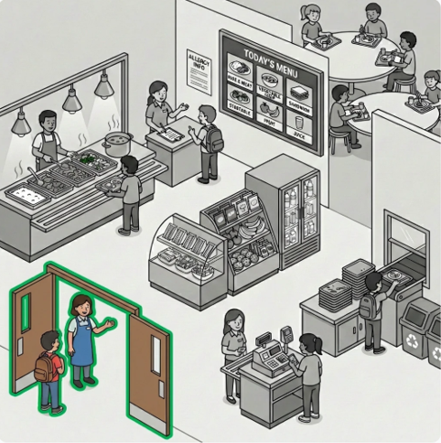

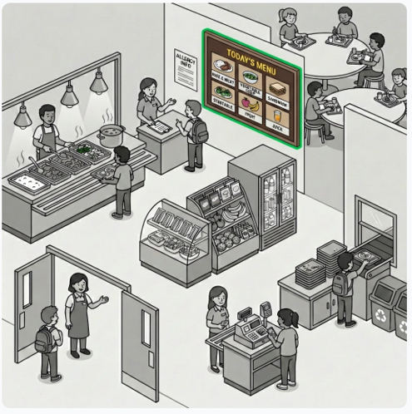

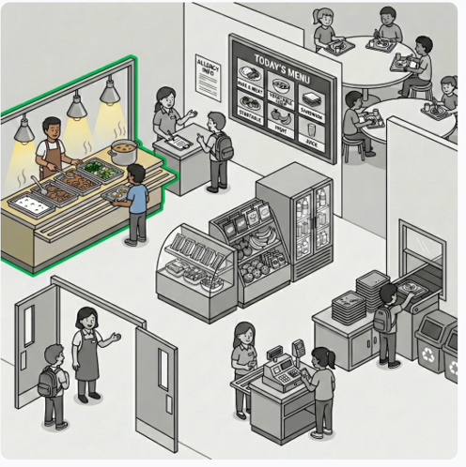

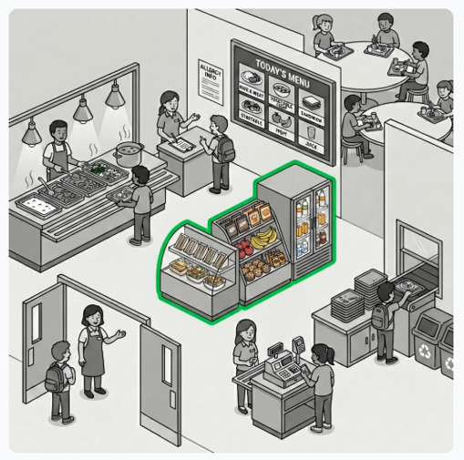

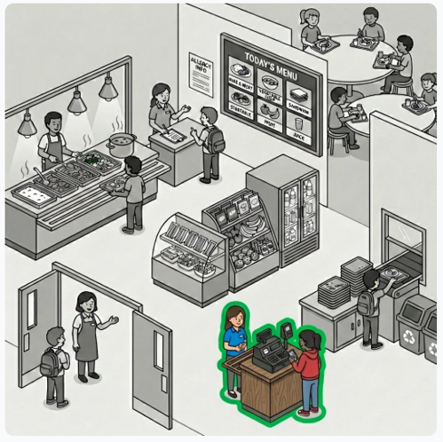

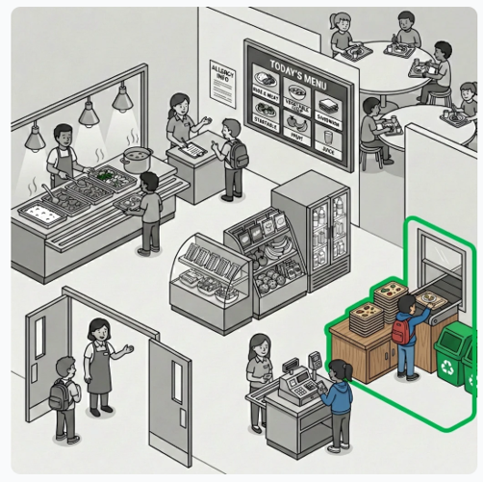

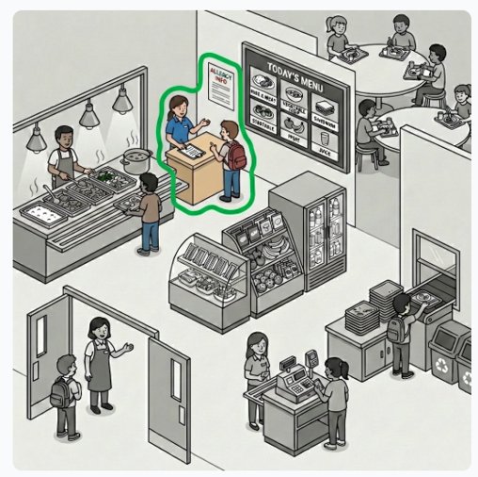

Task 2

Answer the interviewer’s questions.

